**View Vehicle Detail Form**

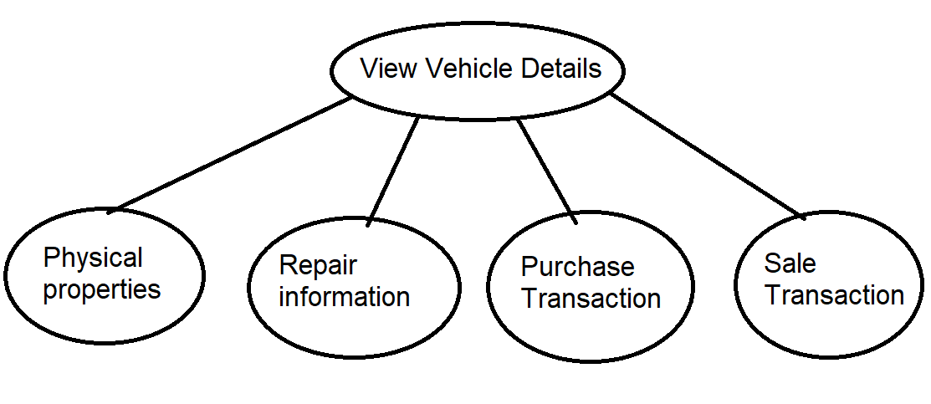

Lock Types: Read-only on Vehicle, User, Customer, Repair, Buy transaction, Sell transaction and Recall Table.

Number of Locks: 7

Enabling Conditions: Enabled by clicking “***Add Repair Form***” button on public search or employee search result list

Frequency: About 500 view vehicle detail per day

Consistency (ACID): Not critical, order is not critical.

Subtasks: Mother Task is needed. Decomposed into three subtasks.

**Business Logic Constraints:**

All have access to physical properties subtask;

Only inventory clerk, manager and owner have access to repair information subtask;

Only manager and owner have access to transactions information;

Salesperson and owner have a link to Sell Vehicle;

Inventory clerk and owner have links to Add Repair and Edit repair button;

If Repair.Status is ‘complete’ or Vehicle.VIN not in Repair table, no Add Repair nor Edit is allowed;

If Vehicle.VIN in Sell_transaction table, neither changes in repair nor sell vehicle is allowed;

Repair.End_date is later than Repair.Start_date;

Repair.Cost >= 0;

Mileage >= 0;

Year is later than 1900-01-01;

Vehicle.Sale_price = Vehicle.Purchase_price * 125% + Σ Repair.Cost * 110%;

**Abstract Code:**

1. Show ***View Vehicle Detail*** in on public search or employee search result list
2. Upon:
   * Click ***View Vehicle Detail*** button;

If *user_type* is ‘inventory_clerk’:

View physical properties, and repair information; Show Add Repair and Edit Repair button; Show Repair Description pop-out button;

Upon click Repair Description pop-out button:

View Repair.description;

If *user_type* is ‘salesperson’:

View physical properties; Show Sell Vehicle button;

If *user_type* is ‘manager’:

View physical properties, repair information, transactions information; Show Repair Description pop-out button;

Click Repair Description pop-out button:

View Repair.description;

If *user_type* is ‘owner’:

View physical properties, repair information, transactions information; Show Add Repair and Edit Repair button; Show Repair Description pop-out button; Show Sell Vehicle button;

Click Repair Description pop-out button:

View Repair.description;

Else:

View physical properties;

* + Click ***Done*** button - Go back to search result list

**Add Customer Form**

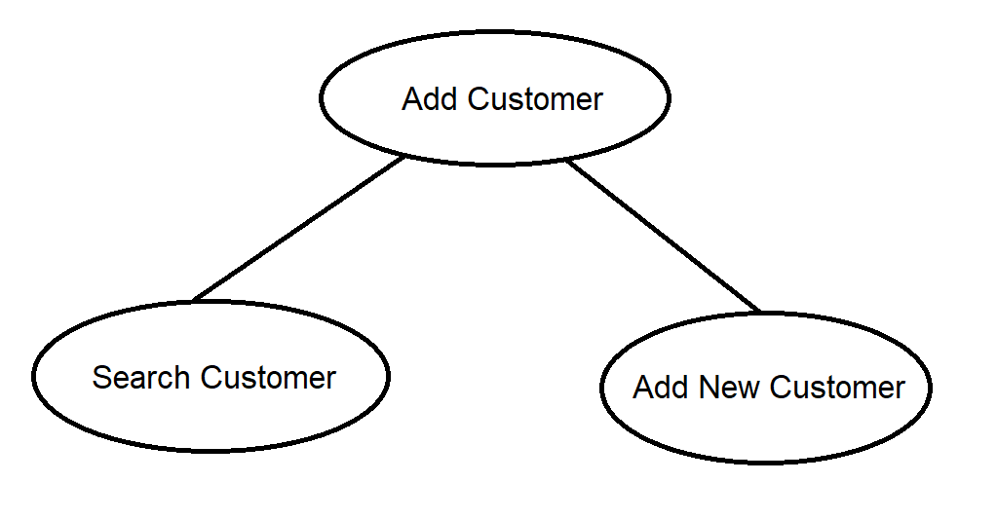

Lock Types: Read and write on Customer Table; Read-only on User Table

Number of Locks: 2

Enabling Conditions: Enabled by clicking “***Add Customer***” button on public search or employee search result list

Frequency: About 20 add customer per day

Consistency (ACID): Search runs prior to add new customer

Subtasks: Mother Task is needed. Decomposed into four subtasks.

Business Logic Constraints:

If person is selected in add new customer subtask, DL and Name are not null while TIN, Business_name, Primary_contact_name and Primary_contact_title are forced to be null;

If business is selected in add new customer subtask, DL and Name are forced to be null while TIN, Business_name, Primary_contact_name and Primary_contact_title are not null;

Datatype:

Address: String, not null;

Email: String, nullable;

Phone: Integer, not null;

Name: String, nullable (see constraints);

DL: String, nullable (see constraints);

TIN: String, nullable (see constraints);

Business_name: String, nullable (see constraints);

Primary_contact_name: String, nullable (see constraints);

Primary_contact_title: String, not nullable (see constraints);

**Abstract Code:**

1. Show ***Add Customer*** upon clicking Sell Vehicle button or Add Vehicle button.
2. Upon:
   * Click ***Add Customer*** button;

Run Search Customer subtask, user enter DL or TIN;

If input DL or TIN in Customer.DL or Customer.TIN:

View Customer where input DL = Customer.DL; Show Edit Customer button;

Upon Click Edit Customer:

Show Edit Customer Form;

Click Save button: Write to Customer Table; Return to Edit Customer;

Click Cancel button: Return to View Customer;

If input DL or TIN not in Customer.DL or Customer.TIN:

Show Add New Customer Form;

User select either Person or Business;

If Person is selected:

User enter address, email (optional), phone_number, first_name, last_name;

Click Save button: Write to Customer Table; Return to Add Customer; View customer;

Click Cancel button: Return to Add New Customer;

If Business is selected:

User enter address, email, phone_number, business_name, primary_contact_name, primary_contact_title;

Click Save button: Write to Customer Table; Return to Add Customer; View customer;

Click Cancel button: Return to Add New Customer;

* + Click ***Done*** button – Go back to Add New Vehicle Form (inventory clerk) or Sale Vehicle Form (salesperson)

**Sale Order Form**

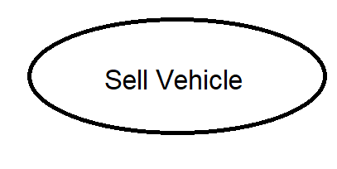

Lock Types: Read and write on Sell_Transaction Table; Read-only on Vehicle, User and Customer Table;

Number of Locks: 4

Enabling Conditions: Enabled by clicking “***Sell Vehicle***” button on vehicle detail form

Frequency: About 10 add sell vehicle per day

Consistency (ACID): Search runs prior to add new customer

Subtasks: No decomposed is needed.

Business Logic Constraints:

Sales date should be later than vehicle purchase date;

If VIN is in sale Transaction.VIN, no further sale transaction is allowed.

Datatype:

Sale_date: Timestamp

**Abstract Code:**

1. Show ***Sell Vehicle*** on vehicle detail screen.
2. Upon:
   * Click ***Sell Vehicle*** button;

Show Add Customer button;

Then show Sale Order Form;

User enters sale_date;

Click Done button: Write into Sell_Transation Table; Display Vehicle detail form;

Click Cancel Button: Return to Vehicle Detail Form;